20RD006CUS SYSTEM MODEL website
The official support and driver portal for the ThinkPad E15 (Type 20RD / Model 20RD006CUS) is hosted on Lenovo's PC Support site:
Official Product Support & Downloads: Lenovo PC Support - ThinkPad E15 (Type 20RD) How to direct-navigate to your specific drivers:
Open the Lenovo PC Support Page.
Click Manual Update and select Mouse, Pen and Touchpad or Motherboard Devices (Core Chipset).
Drivers & Software
For automated updates, open Lenovo Vantage or run Lenovo System Update to pull the signed drivers directly from Lenovo's servers.

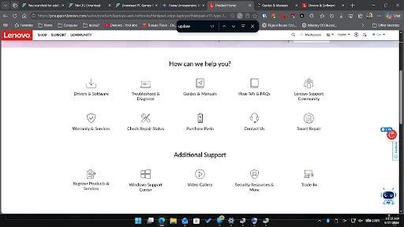i

To download and update the touchpad driver from that screen on Lenovo's support portal, follow these steps:
JPG 1
Access Manual Update
Locate the touchpad drivers section

- Access Manual Update:Locate the touchpad drivers section.
Click on the Drivers & Software tile (top-left tile with the download icon). Click the Manual Update tab at the top of the new page.
Scroll down the component categories and expand Mouse, Touchpad, Keyboard and Pen. 2
Download the Synaptics/ELAN driver Select and download the driver package
- Download the Synaptics/ELAN driver:Select and download the driver package. Locate the Touchpad Driver (ELAN, Synaptics) entry.
Ensure the dropdown is set to your operating system (Windows 10 64-bit or Windows 11). Click Download (or the down arrow icon) to save the .exe installer to your system.
3
Install the driver
Run the setup wizard to replace current drivers
- Install the driver:Run the setup wizard to replace current drivers.
Open your Downloads folder and right-click the downloaded Lenovo installer file. Select Run as administrator.
Follow the installation wizard prompts, select Install, and allow the setup to overwrite existing touchpad drivers.
Reboot your system when prompted.
If you prefer an automated update through Lenovo software instead of manual installation, open the Lenovo Vantage app installed on your machine and run System Update to automatically pull and install Lenovo-certified drivers.

which option should i click there?
Click on Drivers & Software (the top-left tile featuring the laptop and down-arrow icon). JPG

Once you click that, follow these steps:
Click the Manual Update tab at the top of the next page.
Scroll down and click on Mouse, Touchpad, Keyboard and Pen to expand it. Download the Touchpad Driver (ELAN, Synaptics) file for your operating system.
Run the downloaded installer file, follow the wizard instructions, and restart your laptop.

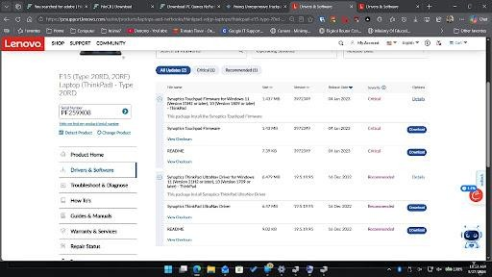

which one should i downlaod?
Download the Synaptics ThinkPad UltraNav Driver (the second group shown on your screen): JPG
Click the blue Download button right next to Synaptics ThinkPad UltraNav Driver (6.47 MB). JPG
Run the downloaded file, complete the setup wizard, and restart your laptop. Next Step if standard drivers don't fix it:
If the buttons still don't respond after updating UltraNav, download and run the blue Download button for Synaptics Touchpad Firmware (1.43 MB, top section). That updates the low-level firmware on the controller chip itself to fix unresponsive input states.
JPG

How do I enter the ThinkPad BIOS to check if the trackpad buttons respond there?
To access the BIOS on your ThinkPad E15 and test if the trackpad buttons respond at a hardware level:
Shut down your ThinkPad completely.
Press the power button to turn it back on, and immediately tap F1 repeatedly until the Lenovo splash screen appears and opens the ThinkPad Setup / BIOS Utility. (If tapping F1 doesn't work, tap Enter repeatedly right after pressing power to interrupt startup, then press F1 from the menu).
Once in the BIOS menu, attempt to navigate using the trackpad and click on any sub-menu options using the physical left and right trackpad buttons.
Interpreting the Result:
If the buttons work in BIOS: The hardware itself is functional. The issue is strictly software-, driver-, or registry-related within Windows.
If the buttons do NOT work in BIOS: The physical buttons or the underlying trackpad ribbon cable connection inside the laptop have likely failed or come loose.
okay when in bios, what do i do?
When you are inside the ThinkPad Setup (BIOS) screen, perform these two simple checks:
Test the Physical Buttons: Move the mouse pointer around using the touchpad. Try clicking on menu tabs (like Config, Security, or Startup) using the physical trackpad buttons (the left and right click buttons).
If clicking works: The trackpad hardware is 100% fine. The issue is purely a software or driver conflict in Windows.
If clicking fails: The hardware switch mechanism or internal ribbon cable has failed. Verify Touchpad is Enabled in BIOS Settings:
Use your arrow keys to navigate to Config. Select Keyboard/Mouse.
Ensure TrackPad is set to [Enabled]. If it says [Disabled], press Enter, change it to [Enabled], then press F10 to save and exit.
Once you have tested the buttons, press Esc and select Exit Without Saving (or press F10 if you changed the TrackPad setting to Enabled) to reboot back into Windows.
what about the red thing on my keyboard that moves the mouse.

That red rubber cap in the middle of your keyboard is the TrackPoint (or pointing stick). It functions as a mini-joystick to control the mouse pointer without moving your hands away from the main keys.
If the TrackPoint is not moving the cursor or its dedicated buttons (the three buttons located right above your trackpad) aren't responding, check these settings:
1
Check Lenovo Commercial Vantage / TrackPoint settings Enable TrackPoint in Windows Lenovo settings
Press Win + S, type Lenovo Vantage (or Lenovo Commercial Vantage), and open it. Go to Device > Input & Accessories (or Smart Assist).
Ensure the TrackPoint toggle is turned On. 2
Check Windows Mouse Properties
Re-enable TrackPoint from Windows Mouse Properties Press Win + R, type main.cpl, and press Enter.
Look for the ThinkPad or UltraNav tab at the top. Ensure the checkbox for Enable TrackPoint is checked. Click Apply and OK.
3
Verify TrackPoint status in BIOS
Verify hardware state at the firmware level
Restart your ThinkPad and tap F1 at startup to enter the BIOS menu. Navigate to Config > Keyboard/Mouse.
Check that TrackPoint is set to [Enabled]. Press F10 to save changes and restart.
If you previously installed the Synaptics ThinkPad UltraNav Driver from Lenovo's site, that driver controls both the touchpad and the TrackPoint together.

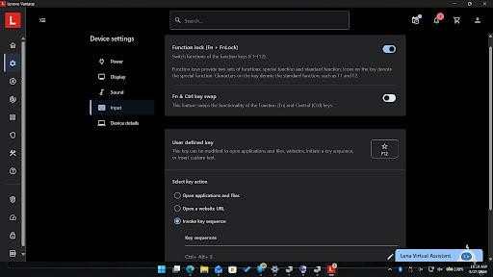

Scroll down on that same Input page in Lenovo Vantage. The TrackPoint and Touchpad controls are located further down below the keyboard shortcut settings:
JPG+ 1
Scroll down the main panel past "User defined key". JPG
Look for the TrackPoint and TouchPad toggle switches.
Make sure both TrackPoint and TouchPad are switched to On.
If you scroll down and those toggles are completely missing from Lenovo Vantage, Windows is using a generic Microsoft driver instead of the Lenovo UltraNav software. To restore them:
Run the Synaptics ThinkPad UltraNav Driver installer file you downloaded earlier.
Reboot your laptop, then reopen Lenovo Vantage—the TrackPoint and Touchpad settings cards will appear.

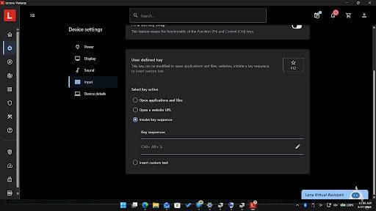

Since the scrollbar is at the bottom and there are no TrackPoint or Touchpad sections showing in Lenovo Vantage, the proprietary Lenovo ThinkPad driver software isn't actively communicating with Vantage.
Run the driver installer file you downloaded from the website earlier: Open your Downloads folder.
Double-click the Synaptics ThinkPad UltraNav Driver installer (.exe) file. Follow the wizard setup to finish the installation, then restart your laptop.
Once the laptop reboots, Windows will load the official UltraNav driver, and those settings will automatically populate in Windows and Lenovo Vantage.

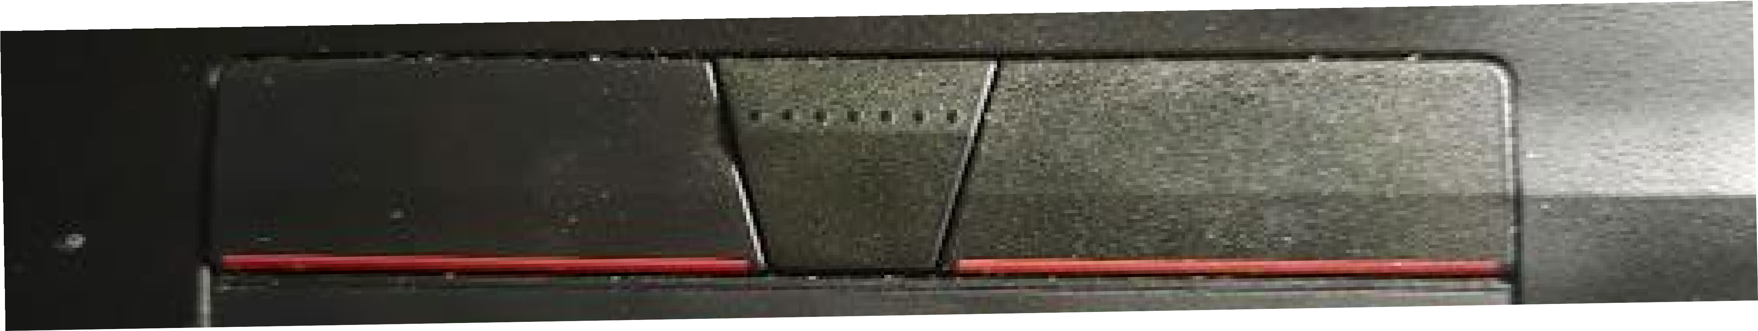

Still don't work

Those physical buttons pictured are part of the upper TrackPoint button assembly, which interfaces directly through the main keyboard cable rather than the lower touchpad surface.
Because updating the drivers didn't restore them and Lenovo Vantage isn't recognizing the input device, work through these diagnostic checks:
1
Check tactile feedback Confirm physical button travel
Press down firmly on the left, middle, and right upper buttons.
Ensure you feel a distinct mechanical click. If a button feels mushy or stuck, dust or small debris under the keycap might be blocking the contact switch.
2
Switch to the native Precision Touchpad driver
Rule out driver conflicts by using generic Windows input drivers Right-click the Start button and open Device Manager.
Expand Mice and other pointing devices.
Right-click your touchpad/pointing device and select Update driver.
Click Browse my computer for drivers > Let me pick from a list of available drivers on my computer.
Select HID-compliant mouse or PS/2 Compatible Mouse, click Next, and reboot. 3
Check internal keyboard ribbon connection Direct hardware inspection
On ThinkPad E15 models, the upper TrackPoint buttons run through the main keyboard ribbon cable beneath the top bezel.
If the laptop was previously bumped or serviced, the ribbon cable under the keyboard deck may be unseated. Reseating the keyboard ribbon connector on the motherboard will restore contact to both the TrackPoint stick and these three upper buttons.

How to fix the FN Keys?

Download Lenovo Vantage. ^{ii}

^{i} Drivers & Software
^{ii} Lenovo Vantage | Lenovo US

